SHAHUL HAMEED TA

Mobile No : *+971 502321265*

Email : *t* [*ashahul70@gmail.com*](mailto:ashahul70@gmail.com)

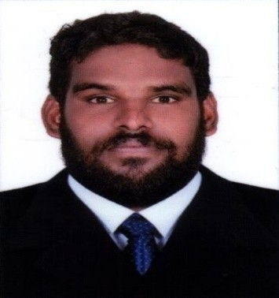

### P ERSONAL ADDRESS

*Thirutthi Athanikkal(H) Parppuram Kadanchery (PO) Kalady*

*Malappuram (DT) Pin-679582*

*Kerala-India*

### P ERSONAL PROFILE

*Date of Birth :18-02-1997 Sex :Male*

*Father Name :Aboobacker T A Mother’s Name :Hyrunnessa*

*Nationality :Indian Marital Status :Single*

### L ANGUAGES KNOWN

* *English*
* *Malayalam*

**I NTERESTS AND HOBBIES**

* *Reading*
* *Traveling*
* *Watching entertaining programs*

**P RACTICAL SKILLS**

* *Good attitude self confident*
* *Ability to work efficiency and quickly*
* *Hard working*
* *Honest and friendly person*

# CAREER FOCUS

## *Kindly requesting to consider me for a suitable vacancy in your reputed firm , where my abilities and experiences can be utilized to the maximum level for the progress of the firm.*

**ACADEMIC PROFILE**

* + ***SSLC*** *(Board of Education Department , Kerala*

*– India -2014)*

**TECHNICAL QUALIFICATION**

* + ***KGCE*** *(Department of Automobile Engineering*

*– 2018)*

* + ***CEDT*** *(Council for Educational Development and Technology - 2018)*

**EXPERIENCE**

* ***Company*** *: SKY HiGH MOTORS.LTD*
* ***Period*** *: 20-04-2019 TO 20-09-2020*
* ***Details*** *:*

*Skyhigh motors (PVT) Limited as a “****store keeper”*** *in service department*

**DECLARATION**

*I hereby declare that the above mentioned details are true and correct to my knowledge and belief*

**Date** : *26-09-2021* **Place**:*MALAPPURAM*

**SHAHUL HAMEED T A**